**Running the project - Execution of Order Matching Engine**

**Jar Build Steps:**

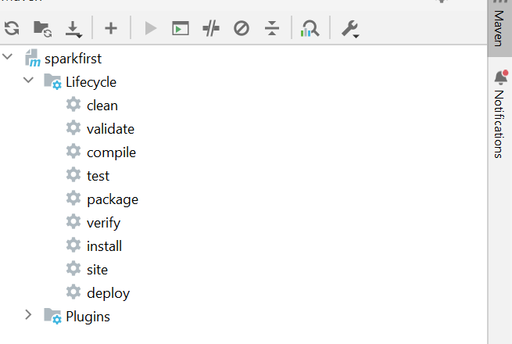

**Pom.xml**

*<?*xml version="1.0" encoding="UTF-8"*?>*<project xmlns="http://maven.apache.org/POM/4.0.0"  
 xmlns:xsi="http://www.w3.org/2001/XMLSchema-instance"  
 xsi:schemaLocation="http://maven.apache.org/POM/4.0.0 http://maven.apache.org/xsd/maven-4.0.0.xsd">  
 <modelVersion>4.0.0</modelVersion>  
  
 <groupId>org.example</groupId>  
 <artifactId>FXENGINEPROJECT</artifactId>  
 <version>1.0-SNAPSHOT</version>  
  
 <properties>  
 <project.build.sourceEncoding>UTF-8</project.build.sourceEncoding>  
 <project.reporting.outputEncoding>UTF-8</project.reporting.outputEncoding>  
  
 <java.version>1.8</java.version>  
 <scala.version>2.11.11</scala.version>  
 <spark.version>2.4.3</spark.version>  
 <scala.compat.version>2.11</scala.compat.version>  
 </properties>  
  
 <dependencies>  
 *<!-- scala-maven-plugin determines the Scala version to use from this dependency -->* <dependency>  
 <groupId>org.scala-lang</groupId>  
 <artifactId>scala-library</artifactId>  
 <version>${scala.version}</version>  
  
 </dependency>  
 *<!-- https://mvnrepository.com/artifact/org.apache.spark/spark-core -->* <dependency>  
 <groupId>org.apache.spark</groupId>  
 <artifactId>spark-core_${scala.compat.version}</artifactId>  
 <version>${spark.version}</version>  
 </dependency>  
  
 *<!-- https://mvnrepository.com/artifact/org.apache.spark/spark-sql -->* <dependency>  
 <groupId>org.apache.spark</groupId>  
 <artifactId>spark-sql_${scala.compat.version}</artifactId>  
 <version>${spark.version}</version>  
 </dependency>  
 <dependency>  
 <groupId>org.apache.hadoop</groupId>  
 <artifactId>hadoop-common</artifactId>  
 <version>2.10.0</version>  
 </dependency>  
 <dependency>  
 <groupId>org.scalatest</groupId>  
 <artifactId>scalatest_2.11</artifactId>  
 <version>3.3.0-SNAP3</version>  
 <scope>test</scope>  
 </dependency>  
 <dependency>  
 <groupId>jdk.tools</groupId>  
 <artifactId>jdk.tools</artifactId>  
 <version>1.8</version>  
 <scope>system</scope>  
 <systemPath>C:/program Files/Java/jdk1.8.0_202/lib/tools.jar</systemPath>  
 </dependency>  
  
 </dependencies>  
  
 <build>  
 <sourceDirectory>src/main/scala</sourceDirectory>  
 <testSourceDirectory>src/test/scala</testSourceDirectory>  
  
 <plugins>  
 *<!-- Configure maven-compiler-plugin to use the desired Java version -->* <plugin>  
 <groupId>org.apache.maven.plugins</groupId>  
 <artifactId>maven-compiler-plugin</artifactId>  
 <version>3.8.0</version>  
 <configuration>  
 <source>${java.version}</source>  
 <target>${java.version}</target>  
 </configuration>  
 </plugin>  
  
  
 *<!-- Use build-helper-maven-plugin to add Scala source and test source directories -->* <plugin>  
 <groupId>org.codehaus.mojo</groupId>  
 <artifactId>build-helper-maven-plugin</artifactId>  
 <version>3.0.0</version>  
 <executions>  
 <execution>  
 <id>add-source</id>  
 <phase>generate-sources</phase>  
 <goals>  
 <goal>add-source</goal>  
 </goals>  
 <configuration>  
 <sources>  
 <source>src/main/scala</source>  
 </sources>  
 </configuration>  
 </execution>  
 <execution>  
 <id>add-test-source</id>  
 <phase>generate-test-sources</phase>  
 <goals>  
 <goal>add-test-source</goal>  
 </goals>  
 <configuration>  
 <sources>  
 <source>src/test/scala</source>  
 </sources>  
 </configuration>  
 </execution>  
 </executions>  
 </plugin>  
  
 <plugin>  
 <groupId>org.apache.maven.plugins</groupId>  
 <artifactId>maven-surefire-plugin</artifactId>  
 <version>2.7</version>  
 <configuration>  
 <skipTests>true</skipTests>  
 </configuration>  
 </plugin>  
  
 <plugin>  
 <groupId>org.scalatest</groupId>  
 <artifactId>scalatest-maven-plugin</artifactId>  
 <version>2.2.0</version>  
 <configuration>  
 <reportsDirectory>${project.build.directory}/surefire-reports</reportsDirectory>  
 <junitxml>.</junitxml>  
 <filereports>WDF TestSuite.txt</filereports>  
 </configuration>  
 <executions>  
 <execution>  
 <id>test</id>  
 <goals>  
 <goal>test</goal>  
 </goals>  
 </execution>  
 </executions>  
 </plugin>  
 *<!-- Use scala-maven-plugin for Scala support -->* <plugin>  
 <groupId>net.alchim31.maven</groupId>  
 <artifactId>scala-maven-plugin</artifactId>  
 <version>3.2.2</version>  
 <executions>  
 <execution>  
 <goals>  
 *<!-- Need to specify this explicitly, otherwise plugin won't be called when doing e.g. mvn compile -->* <goal>compile</goal>  
 <goal>testCompile</goal>  
 </goals>  
 </execution>  
 </executions>  
 </plugin>  
  
 *<!-- scala assembly-->* <plugin>  
 <groupId>org.apache.maven.plugins</groupId>  
 <artifactId>maven-assembly-plugin</artifactId>  
 <version>2.4</version>  
 <configuration>  
 <descriptorRefs>  
 <descriptorRef>jar-with-dependencies</descriptorRef>  
 </descriptorRefs>  
 </configuration>  
 <executions>  
 <execution>  
 <phase>package</phase>  
 <goals>  
 <goal>single</goal>  
 </goals>  
 </execution>  
 </executions>  
 </plugin>  
 </plugins>  
 </build>  
</project>

Through this process I have added Dependencies to project to run import commands.

**Steps To Build The jar From Intellij IDE:**

**1.Install Java8 :**

To install Apache Spark on windows, you would need Java 8 or the latest version hence download the Java version from Oracle and install it on your system. If you wanted OpenJDK you can download it from [here](https://www.oracle.com/java/technologies/downloads/#java8).

After download, double click on the downloaded .exe ([jdk-8u371-windows-x64.exe](https://www.oracle.com/java/technologies/downloads/#license-lightbox)) file in order to install it on your windows system. Choose any custom directory or keep the default location.

After installation set JAVA_HOME environment variable.

Eg: JAVA_HOME= C:\Program Files\Java\jdk1.8.0_333

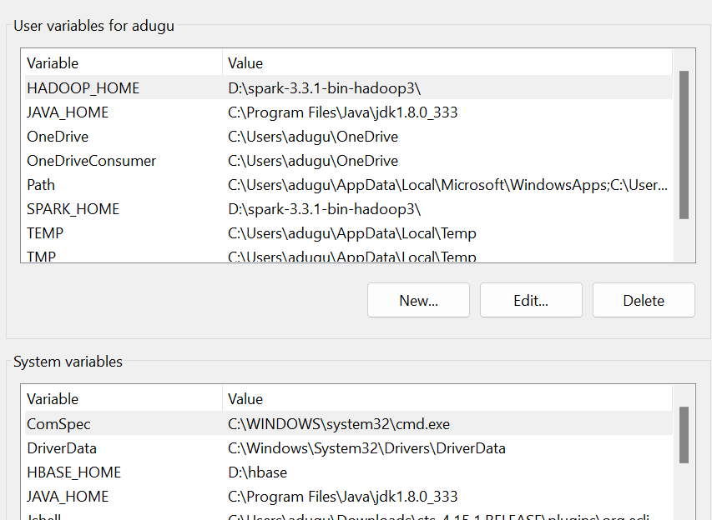

2.Do git clone from the path “https://github.com/jairamyarram/fxengine”

3. Install Intellij IDE:

i. Download and install intellij

ii. Extract the zip file and run.

iii. Select Workspace

Eg: C:\ideaprojects\workspace

4. Import the project from by clicking File -> maven ->compile

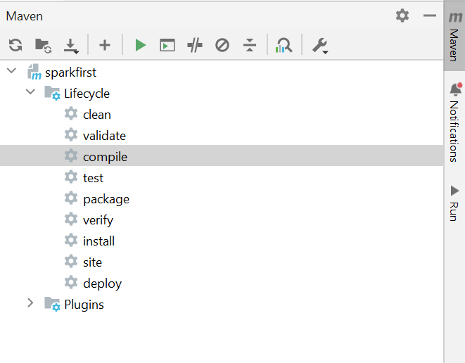

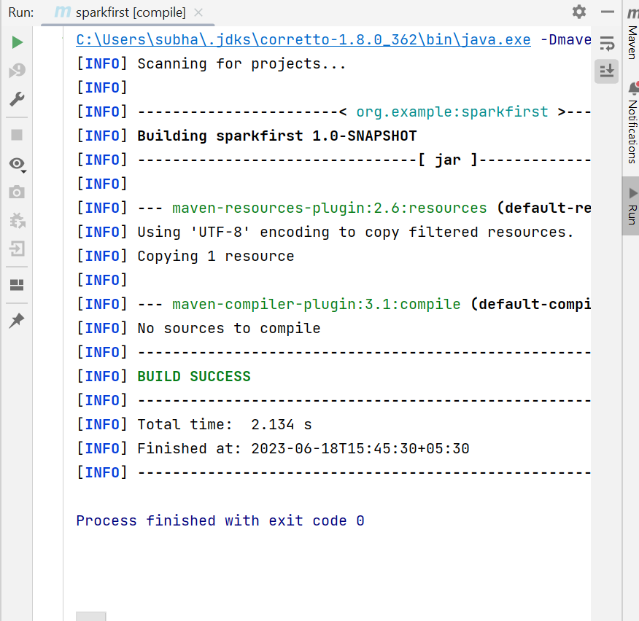

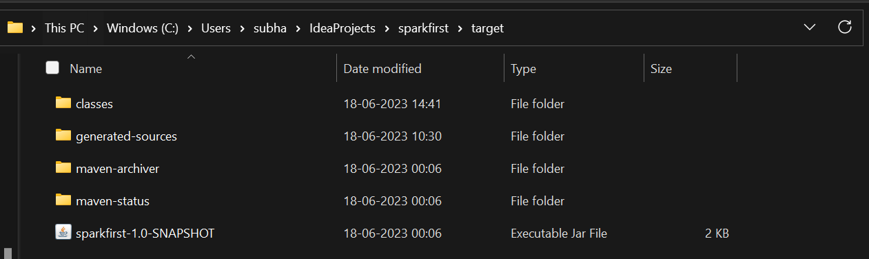

**SparkSubmit:**

spark-submit -–name FXENGINEPROJECT -–master local

-–deploy-mode cluster

--driver-memory 1g

--executor-memory 1g

--executor-cores 4

-–class com.interview.stockexchange C:/Users/subha/IdeaProjects/FXENGINEPROJECT/target/FXENGINEPROJECT-1.0-SNAPSHOT-jar-with-dependencies

file:///C:/data/Sampleinputoutputfiles/input exampleOrders.csv file:///C:/data/Sampleinputoutputfiles/output output.csv